Hospital Consumer Assessment of Healthcare Providers and Systems - Analysis
Yash Kishor Palresha
2025-01-14
# Load the dataset
data <- read.csv("C:/Users/yash/Desktop/HCAHPS_Hospital.csv")
summary(data)
## srno Provider_ID Hospital_Name Address
## Min. : 0 Min. : 10001 Length:254540 Length:254540
## 1st Qu.: 63635 1st Qu.:140171 Class :character Class :character
## Median :127270 Median :251335 Mode :character Mode :character
## Mean :127270 Mean :266301
## 3rd Qu.:190904 3rd Qu.:390137
## Max. :254539 Max. :670108
##
## City State ZIP.Code County.Name
## Length:254540 Length:254540 Min. : 603 Length:254540
## Class :character Class :character 1st Qu.:32801 Class :character
## Mode :character Mode :character Median :55015 Mode :character
## Mean :53715
## 3rd Qu.:75701
## Max. :99929
##
## Phone.Number HCAHPS.Measure.ID HCAHPS.Question
## Min. :9.369e+08 Length:254540 Length:254540
## 1st Qu.:3.869e+09 Class :character Class :character
## Median :6.038e+09 Mode :character Mode :character
## Mean :5.842e+09
## 3rd Qu.:7.877e+09
## Max. :9.899e+09
##
## HCAHPS.Answer.Description Patient_Survey_Star_Rating
## Length:254540 Length:254540
## Class :character Class :character
## Mode :character Mode :character
##
##
##
##
## Patient.Survey.Star.Rating.Footnote HCAHPS.Answer.Percent
## Length:254540 Length:254540
## Class :character Class :character
## Mode :character Mode :character
##
##
##
##
## HCAHPS.Answer.Percent.Footnote HCAHPS_Linear_Mean_Value
## Length:254540 Length:254540
## Class :character Class :character
## Mode :character Mode :character
##
##
##
##
## Number.of.Completed.Surveys Number.of.Completed.Surveys.Footnote
## Length:254540 Length:254540
## Class :character Class :character
## Mode :character Mode :character
##
##
##
##
## Survey.Response.Rate.Percent Survey.Response.Rate.Percent.Footnote
## Length:254540 Length:254540
## Class :character Class :character
## Mode :character Mode :character
##
##
##
##
## Measure.Start.Date Measure.End.Date Location Key
## Length:254540 Length:254540 Length:254540 Length:254540
## Class :character Class :character Class :character Class :character
## Mode :character Mode :character Mode :character Mode :character
##
##
##
##
## RUCC_code Region Facility_Availabity_Score
## Min. :1.000 Length:254540 Min. : 45.00
## 1st Qu.:1.000 Class :character 1st Qu.: 67.00
## Median :3.000 Mode :character Median : 86.00
## Mean :3.689 Mean : 80.42
## 3rd Qu.:6.000 3rd Qu.: 93.00
## Max. :9.000 Max. :100.00
## NA's :16060
# Convert Region to factor
data$Region <- as.factor(data$Region)
# Check for NA values in score
data_clean <- data %>% filter(!is.na(Facility_Availabity_Score))
# Summary statistics
data_clean %>%
group_by(Region) %>%
summarise(
Mean_Score = mean(Facility_Availabity_Score),
Count = n()
)
## # A tibble: 2 × 3
## Region Mean_Score Count
## <fct> <dbl> <int>
## 1 Rural 65.0 111980
## 2 Urban 92.5 142560
# Boxplot
ggplot(data_clean, aes(x = Region, y = Facility_Availabity_Score, fill = Region)) +
geom_boxplot() +
labs(title = "Facility Availability Score by Region",
y = "Facility Availability Score", x = "Region") +
theme_minimal()
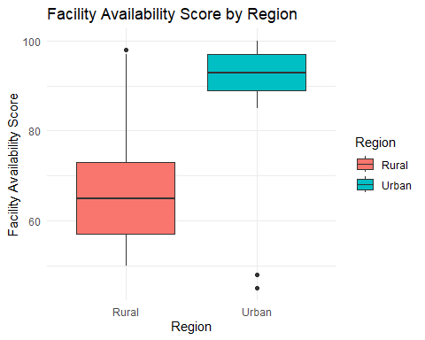
# t test
t_test <- t.test(data_clean$Facility_Availabity_Score ~ data_clean$Region, var.equal=TRUE )
t_test
##
## Two Sample t-test
##
## data: data_clean$Facility_Availabity_Score by data_clean$Region
## t = -1003.2, df = 254538, p-value < 2.2e-16
## alternative hypothesis: true difference in means between group Rural and group Urban is not equal to 0
## 95 percent confidence interval:
## -27.55318 -27.44573
## sample estimates:
## mean in group Rural mean in group Urban
## 65.01440 92.51385
# Compute percent difference
mean_rural <- mean(data_clean$Facility_Availabity_Score[data_clean$Region == "Rural"])
mean_urban <- mean(data_clean$Facility_Availabity_Score[data_clean$Region == "Urban"])
percent_diff <- ((mean_urban - mean_rural) / mean_urban) * 100
cat("Rural hospitals have", round(percent_diff, 1), "% lower facility availability score than urban hospitals.\n")
## Rural hospitals have 29.7 % lower facility availability score than urban hospitals.
# Clean region values
data$Region <- tolower(trimws(data$Region))
# Remove any missing values
data <- subset(data, !is.na(Facility_Availabity_Score) & Region %in% c("rural", "urban"))
# Group Facility Score into bins
data$Facility_Level <- cut(
data$Facility_Availabity_Score,
breaks = c(0, 69, 84, 100), # You can tweak these ranges
labels = c("Low", "Medium", "High"),
right = TRUE,
include.lowest = TRUE
)
# Create contingency table
table_facility <- table(data$Region, data$Facility_Level)
print(table_facility)
##
## Low Medium High
## rural 72232 39743 5
## urban 2 0 142558
# Chi-square test
chisq_result <- chisq.test(table_facility)
print(chisq_result)
##
## Pearson's Chi-squared test
##
## data: table_facility
## X-squared = 254512, df = 2, p-value < 2.2e-16

